Task 11 S3 bucket
1. Create a new S3 bucket in your AWS account with a unique name that includes your initials and the current date (e.g., mybucket-AB-20240618). Set the region to Asia Pacific (Mumbai).
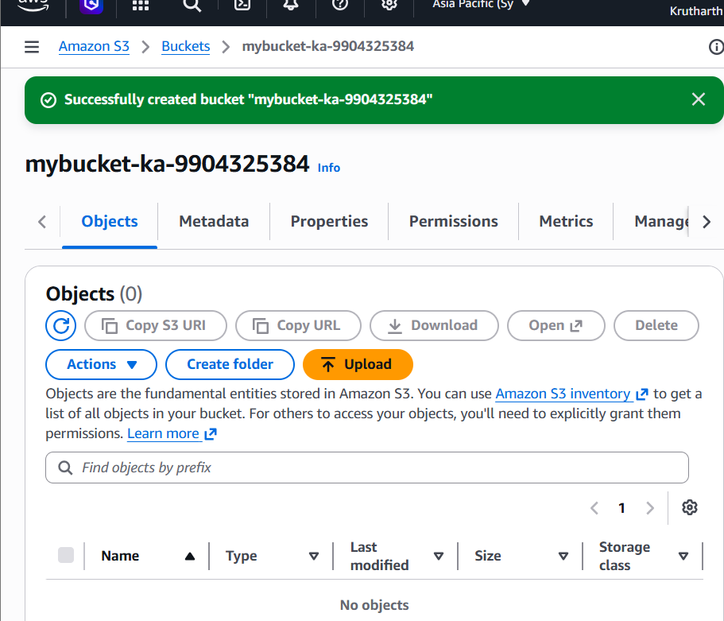
2. Upload three different files (an image, a PDF, and a text file) to your new S3 bucket using the AWS Management Console. Make sure each file has a meaningful name related to your favorite app (e.g., instagram-logo.png, spotify-playlist.pdf, zomato-menu.txt).
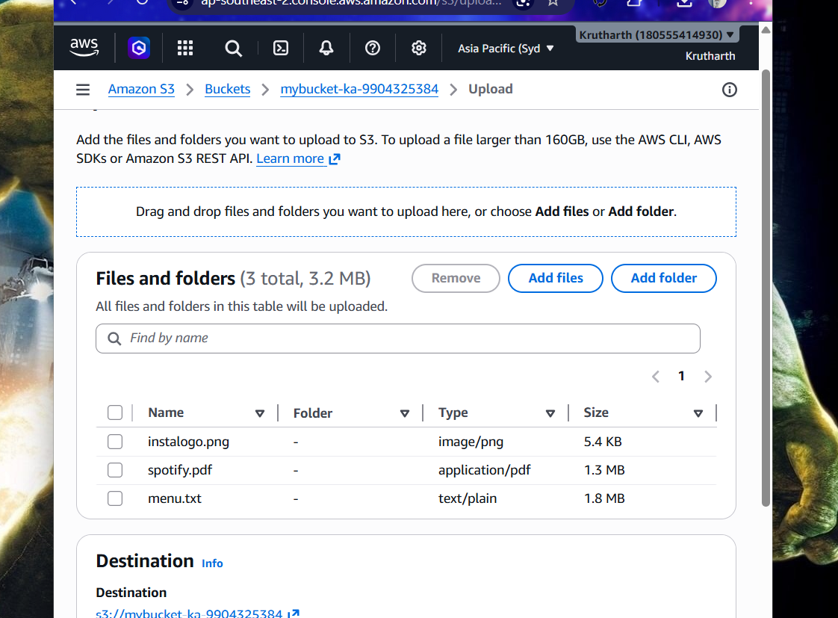

3. Set the access permissions on one of your uploaded files so it is publicly accessible via a URL. Test the link in your browser to confirm it works.<br><br><em><strong>Hint:</strong> Use the 'Make public' option in the AWS S3 console and copy the object URL.</em>
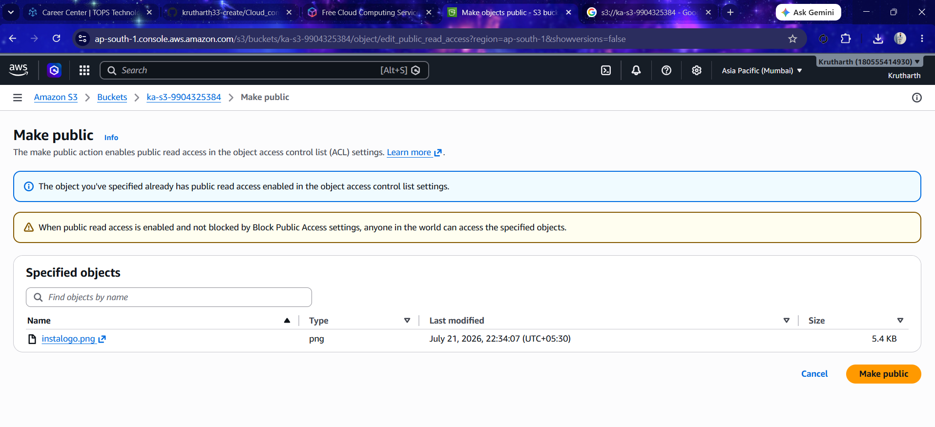
4. Enable versioning on your S3 bucket, then upload a new version of one of your files (e.g., upload an updated zomato-menu.txt with different content). Check the version history to confirm both versions are stored.<br><br><em><strong>Hint:</strong> Use the 'Versions' tab in the bucket to view all versions.</em>

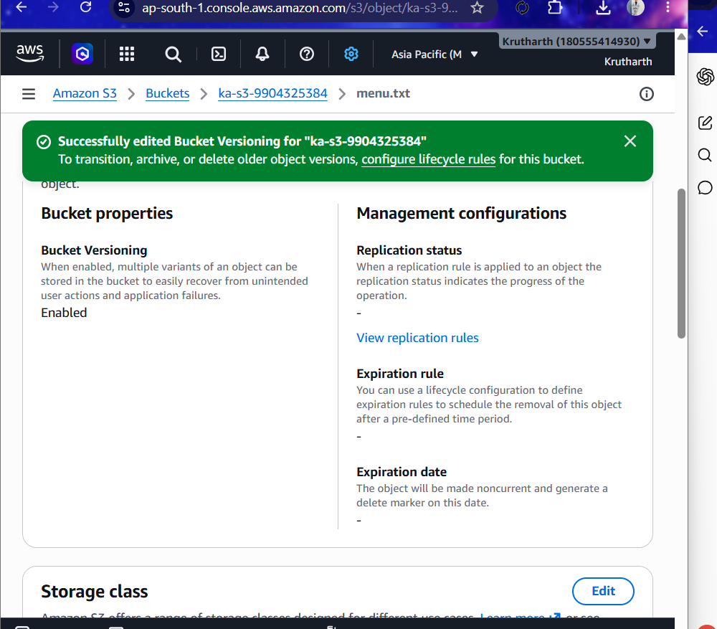

5. Write a short comparison (3-4 sentences) explaining the main differences between AWS S3, EBS, and Glacier. Mention which one you would use for storing Instagram profile pictures, Flipkart order history, and old IRCTC booking records, and why.
Ans:
Feature | Amazon S3 | Amazon EBS | Amazon Glacier
Storage Type | Object Storage | Block Storage | Archive Storage
Performance | High | Very High | Low (retrieval takes minutes or hours)
Best Use | Files, images, videos, backups | EC2 operating systems and databases | Long-term archival and backup
Cost | Moderate | Higher | Lowest

Amazon S3 is best suited for storing frequently accessed files such as Instagram profile pictures because it provides high durability, scalability, and fast access. Amazon EBS is ideal for storing data attached to EC2 instances, such as Flipkart's order processing databases, because it offers low latency and high performance. Amazon Glacier is designed for long-term archival storage and is the best choice for old IRCTC booking records that are rarely accessed but must be retained securely at a low cost.

